Air Quality Monitoring

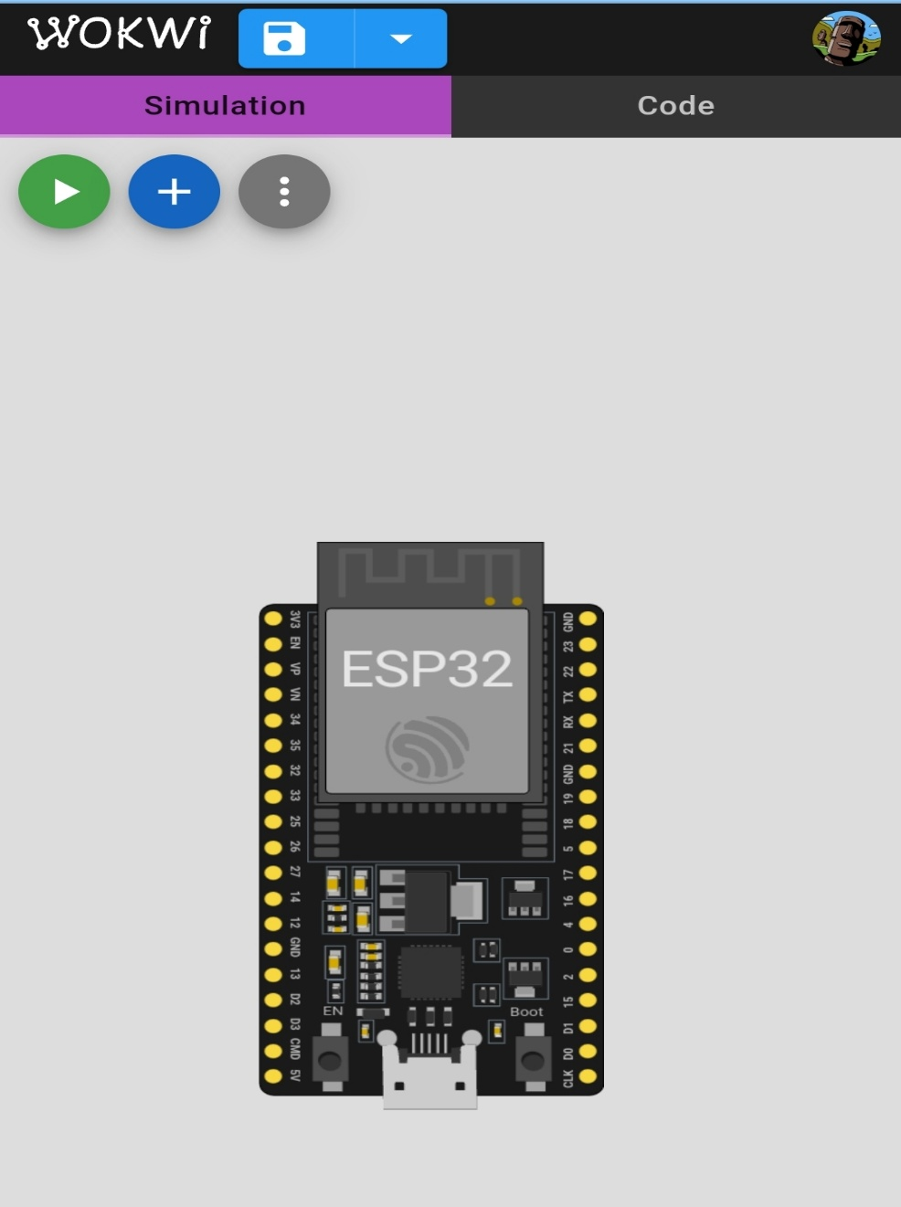This is an ESP32 NodeMCU-based Air Quality Monitoring To check particular matter(PM), Humidity, Temperature, Attitude and Pressure levels. Various Environment conditions of the place area tested and display on the TFT display as well as in ThingsSpeak IoT (Internet of Things) platform.

Components Requirement:

~ESP32

~DHT22

~LCD 16×2(I2C)

~VCC SYMBOL

~GND SYMBOL

~CONNECTING WIRES

Coding for this project:

#include “DHTesp.h”

#include <LiquidCrystal_I2C.h>

#define I2C_ADDR 0x27

#define LCD_COLUMNS 20

#define LCD_LINES 4

Const int DHT_PIN = 15;

DHTesp dhtSensor;

LiquidCrystal_I2C lcd(I2C_ADDR, LCD_COLUMNS, LCD_LINES);

Void setup() {

Serial.begin(115200);

dhtSensor.setup(DHT_PIN, DHTesp::DHT22);

lcd.init();

lcd.backlight();

}

Void loop()

{

TempAndHumidity data = dhtSensor.getTempAndHumidity();

Serial.println(“Temp: “ + String(data.temperature, 1) + “°C”);

Serial.println(“Humidity: “ + String(data.humidity, 1) + “%”);

Serial.println(“---“);

Lcd.setCursor(0, 0);

Lcd.print(“ Temp: “ + String(data.temperature, 1) + “\xDF”+”C “);

Lcd.setCursor(0, 1);

Lcd.print(“ Humidity: “ + String(data.humidity, 1) + “% “);

Lcd.print(“Wokwi Online IoT”);

Delay(1000);

}

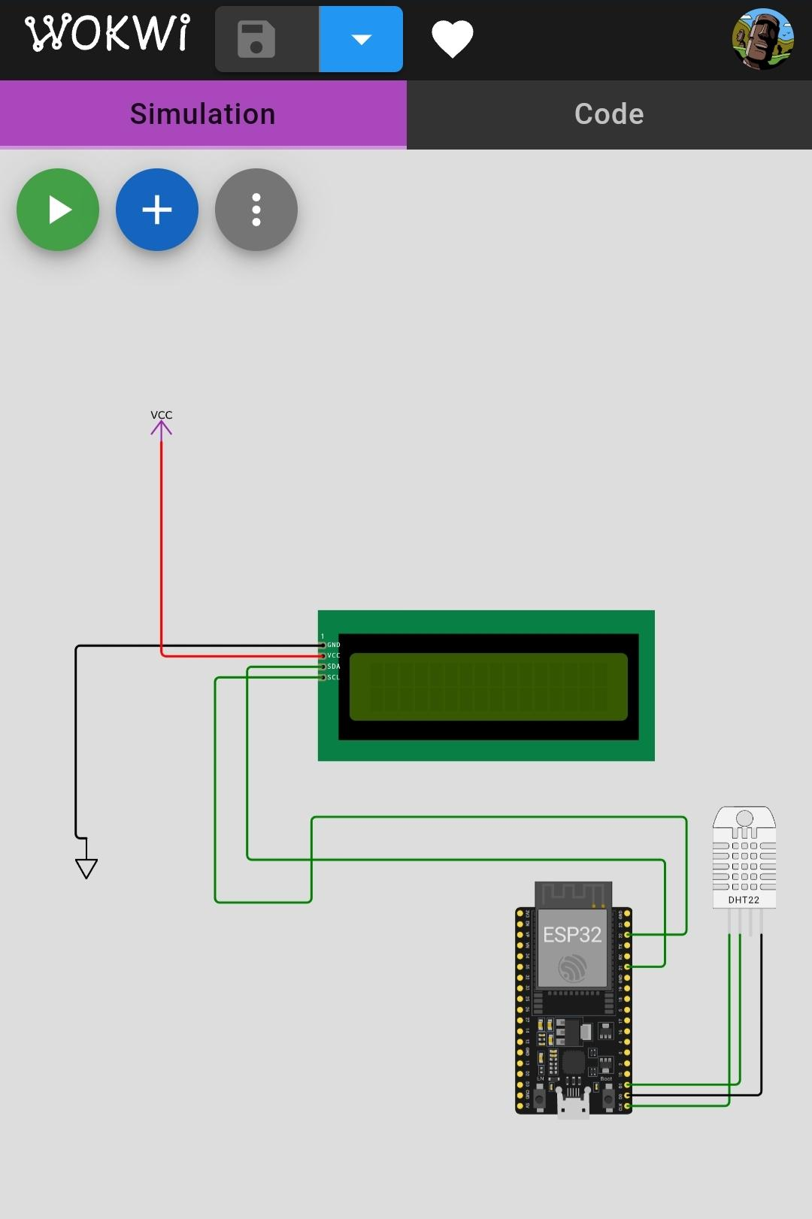

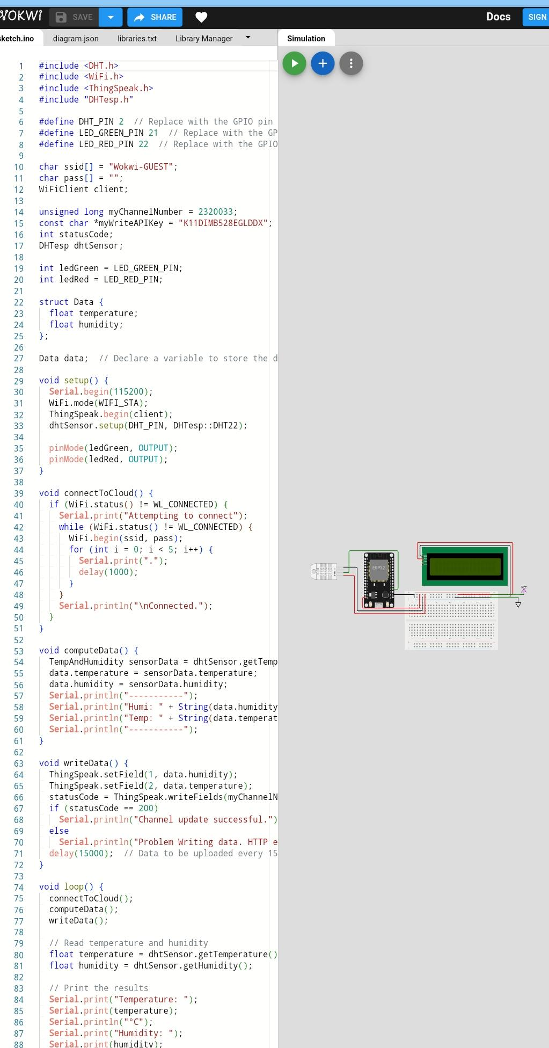

Here's a simplified example of how your code might look for reading and sending data:

Conclusion:

In this platform, users can easily monitor their air quality identify patterns, and make Informed decisions to conserve air. Additionally, the platform can provide insights and Recommendations for air quality monitoring, promoting temperature and humidity real time data.By raising awareness and providing real-time data, this data-sharing platform can contribute to a more Efficient and responsible use of atmosphere, ultimately helping to address air pollution and Environmental concerns.